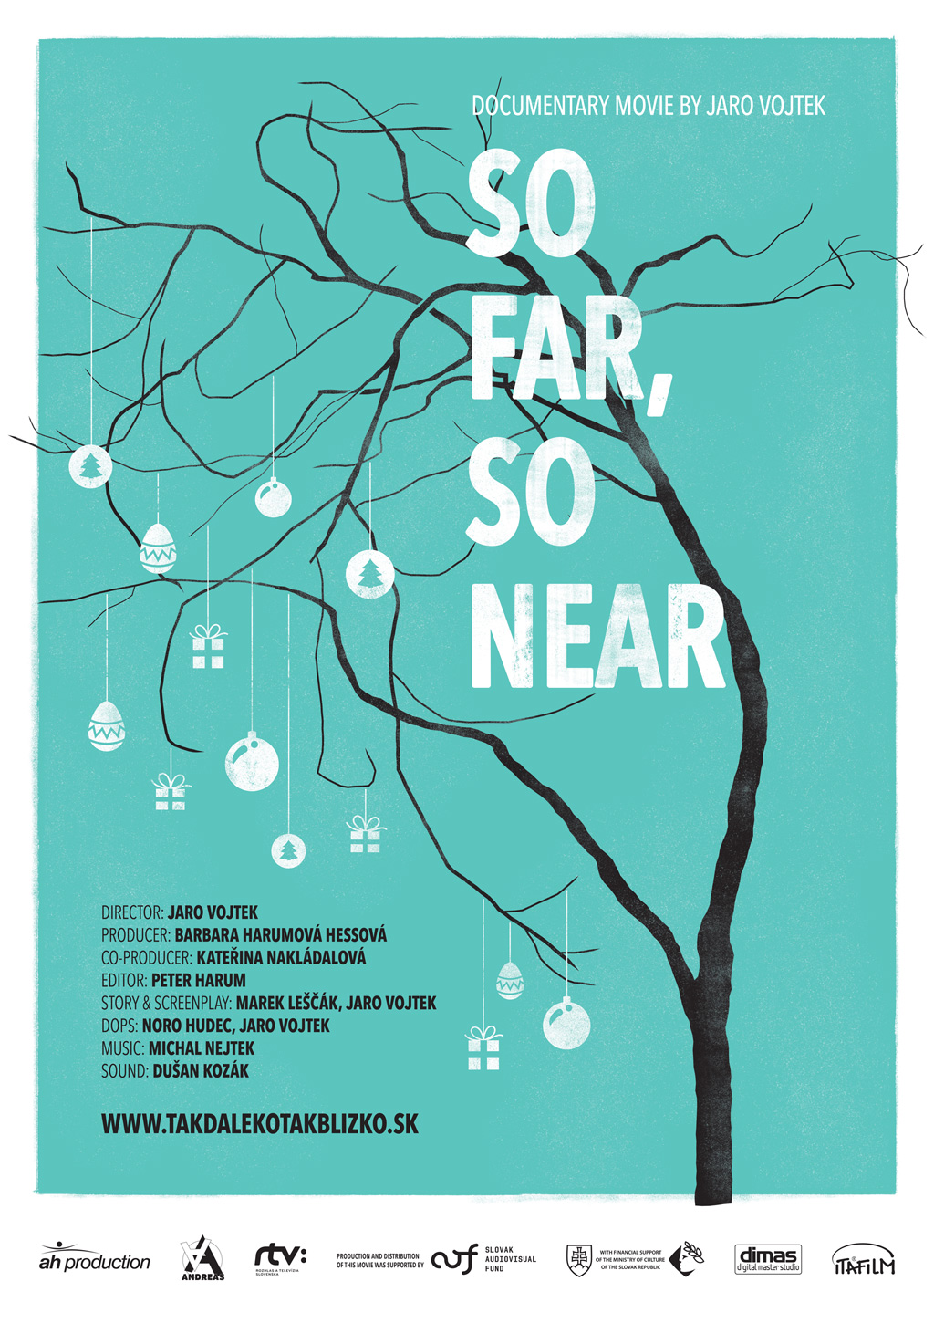
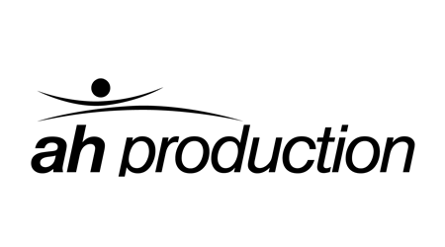 | 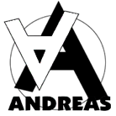

THIS FILM WAS PRODUCED AND DISTRIBUTED WITH FINANCIAL SUPPORT FROM
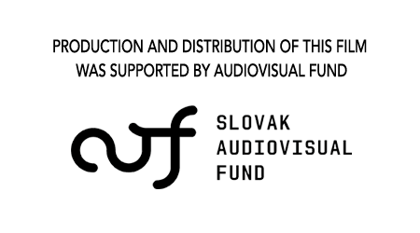
WITH FINANCIAL SUPPORT OF THE MINISTRY OF CULTURE OF THE SLOVAK REPUBLIC
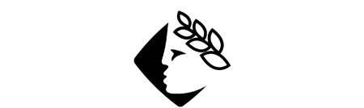

AH production, Andreas n.o. a RTVS - Rozhlas a televízia Slovenska

PRESENT THE DOCUMENTARY FILM

In cooperation with the distribution company
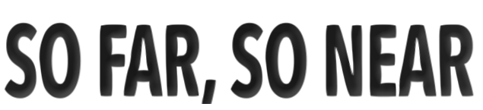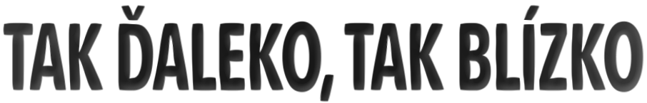
PRODUCER:  Barbara Harumová Hessová  hessova@ah.sk www.ah.sk/en/  + 421 908 786 843  AH production, s.r.o.  Irkutská 14/D | 851 10 Bratislava | Slovakia | PR in Slovakia  Juraj Brocko  +421904466914  pr.itafilm@gmail.com | SLOVAK DISTRIBUTOR:  ITAFILM  +421904466914  ita agentúra, s.r.o.  Priemyselná 1 | 821 09 Bratislava 2 | Slovakia  http://www.itafilm.sk | itafilm@itafilm.sk

SO FAR, SO NEAR

TECHNICAL INFORMATION:

Original language: Slovak
Sub-titles: English
Length: 80 minutes
Film format : 1920×1080 25p, 16:9, COLOUR
Sound format: 5.1
Available on: DCP 25p, Blu-ray, DVD
Genre Documentary
Premiered in: 2015
Produced in: 2014
Copyright: AH production, Andreas n.o., RTVS
Official film website: www.takdalekotakblizko.sk/en
Facebook page: facebook.com/takdalekotakblizko

BRIEF SUMMARY:
The film contemplates the coexistence of autistic children with their parents. It strives to find new ways of looking at this serious disorder of the human psyche. It debunks generally held stereotypes about this disorder and takes up parents‘ issues as well as love between people with autism.

SYNOPSIS:
The film offers a look into the lives of people with autism while challenging generally held opinions in society about this developmental disorder. This is an unusual film about the environment in families with autistic children, which reveals the day-to-day challenge of life with them. It is not, however, built on dialogue and testimony, but on specific, naturally occurring situations in which it contemplates the issues of familial and romantic love for people with autism. The documentary was made over the course of seven years in cooperation with a nonprofit organization called the Andreas Autism Centre, which provides expert and comprehensive support to people with autism, as well as to their families.

DIRECTOR’S COMMENTS:
The theme of autism found me, as with many other themes before that. Katka Nakládalová, who runs the Andreas Autism Centre approached me about making a 20-minute film for the centre’s educational purposes. As I went deeper into the subject of autism however, it didn’t seem sufficient for families with autistic children to have such a small space to present their daily lives. And so I began to work on a feature-length film, which took about seven years. As the parents of these children have realized, I too came to understand with time that it’s not possible to penetrate the world of autism. The only way is to observe it from the outside, get close to it through the children’s relationships with their surroundings and their loved ones. I tried to shoot what is different about life for autistic people, what distinguishes their ordinary existence from ours. People with autism have their needs and it is a question of how the families around them fulfil these needs and to what extent it influences their own lives. One interesting discovery was that these children’s parents had understood that they have to forget about medicines, forget about various treatment methods and try to create the kind of environment that these children need the most, where they feel the best.
For this reason, the film So Far, So Near is about the creation of special relationships between those with autism, their families and the people around them. This symbiosis is often about the denial of one’s own personal needs in favour of the needs of the autistic person. I strived to choose protagonists with various types of autism so that I could create a multi-coloured and more three-dimensional picture of this disorder, which defies (often distorted) generalization. Autism is not about being a genius, being gifted or being totally withdrawn. The relationship of parents to an autistic child is above all about sacrifice and difficult everyday care.
CO-PRODUCERS’ COMMENTS:
It all began with my colleague Martina S’s quite bold idea to make a documentary about autism. When she presented it to us, she said: “And it will be shot by Jaro Vojtek”.
To the rest of us, who had until then had no experience with this subject, the plan seemed too bold. But when we thought more deeply about it, we had to admit that it was just the thing needed to enlighten people. It happened then and happens to this day that people’s consciousness and image of those who have the disorder is significantly distorted. There is an opinion that it is now a modern diagnosis and the number of those diagnosed is growing thanks only to better diagnostic methods. But this cannot be entirely true, since statistics in the world are alarming and indicate a incidence of one child in 100 born as compared to one in 5,000 15-20 years ago. We often meet with another opinion - that these are gifted children who have certain ingenious gifts and capabilities, which we just have to find in them. The film Rainman partially contributed to this distorted point of view. It was one of the first that dealt with this diagnosis on a global scale, but it only presented highly functioning autism in the tiniest representative case. Everyday life with autism is, to a very high degree, diametrically different from the story in the film. It often exists alongside mental retardation, metabolic disorders, aggression and auto-aggression. Causal treatment of autism, despite years-long research efforts, does not exist and the only thing available is behavioural approaches for improving these people’s quality of life and developing their ability to communicate with their surroundings.
In addition to our colleague Martina, to whom we say a big THANK YOU, there were other people on the path to today’s introduction of this film onto the market. Without these people, we would have had trouble orienting ourselves in an area that was new to us. For a nonprofit organization, taking on the role of producer was biting off more than we could chew. So we took Jaro Vojtek’s advice and decided to work together with the production firm AH Production. Thus, our cooperation with producer Barbara Harumova Hessova began. During seven long years, while our long and time-consuming project gradually took shape and became what it is today, lovely friendships also emerged between all of those who took part in the film’s creation. We felt their strong support, for which we are extremely grateful.
Today I am very excited that seven years after we first met with director Jaro Vojtek, a documentary film that strives to bring life with autism in Slovak families closer to the viewer has actually arrived. I believe that in addition to being educational, it will also be a platform for further discussion about this society wide problem that is growing at an alarming rate.

PRODUCER’S COMMENTS:
The making of this film in cooperation with the Andreas Autism Centre began in 2007. Given ANDREAS‘ orientation as a non-profit organization focused on support in diagnosing and dealing with the phenomenon of autism, the beginning of film production was an enormous burden for them. We are happy that we could join the project and oversee its implementation, as well as the production side, so that the film could be completed and brought to viewers in cinemas. For this we thank the Audiovisual Fund, the Ministry of Culture and RTVS for their support. Through archival material shot by the director himself and also from the parents‘ archives, a cross-section of the main characters‘ lives from childhood to adulthood was available. It was complicated to decide what character to give the film, and it actually emerged gradually in the editing room itself while we continued to shoot more and more new situations – moments from the families‘ lives. Originally we shot footage in five families, but such a large quantity of footage couldn’t fit into the film. In terms of time and production efficiency, this was a challenging project because people with autism can only concentrate and deal with being surrounded by film crews for very short periods. For this reason it was not easy to plan and shoot the film in a conventional way. It required a flexible, tolerant and generous approach from the entire film crew, for which we are extremely grateful. For these reasons, our shooting workday was short. From this point of view, a value-oriented, multi-year film project is complicated. We would like to express our enormous gratitude especially to the parents and relatives who allowed us to enter into their often painful private lives. They were willing to open up and share their fate with us. Caring for people with autism is incredibly difficult. Parents and relatives are often misunderstood and disadvantaged in the social context of our society. Together with the staff of AC Andreas, we would like to bring the world of autism closer to the general public and, in so doing, debunk myths and prejudices in an effort to find a more sensitive approach both to people with this diagnosis and to their families.

CREATORS:

STORY, SCRIPT, DIRECTION:
Jaro Vojtek (*1968, Žilina). From 1994-1998 he studied under Dušan Hanák in the documentary film directing department at the Academy of Performing Arts in Bratislava (VŠMU). His full-length film debut My zdes (2005) was shown at the Karlovy Vary film festival and others, where it won many awards, for example, the Main Prize at the Jeden svět (One World) International Film Festival of documentary films on human rights in Prague in 2006. In 2009, his second full-length documentary entitled Hranica (Border) premiered and won an award at the documentary film festival in Jihlava called the Between the Seas Award for best Eastern European documentary film. It was also presented in the prestigious section called Spektrum at the Rotterdam International Film Festival. His documentary Cigáni idú do volieb (Gypsies Go to the Elections, 2012) was shown at international festivals in Warsaw, Jakarta and Minsk and won the Silver Eye Special Jury Prize at the international documentary film festival in Jihlava. Mr. Vojtek is holder of the 2012 Crystal Wing award for audiovisual work.

STORY, SCRIPT:
Marek Leščák (*1971, Bratislava). Marek studied screenwriting and dramaturgy at the Film and Television Faculty of the Academy of Performing Arts, where he continues to teach today. He has worked as a screenwriter on films that won prizes both at home and abroad, including: Záhrada (Garden, directed by Martin Šulík, 1995), Orbis Pictus (directed by Martin Šulík, 1997), Slnečný štát (Sunny Country, directed by Martin Šulík, 2005), My zdes (We are Here, directed by Jaro Vojtek, 2005), Slepé lásky (Blind Love, directed by Juraj Lehotský, 2008), Hranica (Border, directed by Jaro Vojtek, 2009), Ilja (directed by Ivan Ostrochovský, 2010), Cigán (Gypsy directed by Martin Šulík, 2011), Až do mesta Aš (directed by Iveta Grófová, 2012), Ďakujem, dobre (directed by Mátyás Prikler, 2013), Zázrak (Miracle, directed by Juraj Lehotský, 2013), the Slovensko 2.0 film project (the short film Pohreb prezidenta [The President’s Funeral, réžia: Martin Šulík, 2014]), Deti (Children directed by Jaro Vojtek, 2014) and Koza (directed by Ivan Ostrochovský 2015).

PRODUCER:
Barbara Harumová Hessová graduated in film and multimedia production and distribution at the Film and Television Faculty of the Academy of Performing Arts in Bratislava, where she received the Rector’s Prize and subsequently undertook her doctoral studies. She has worked for several production houses on documentary and feature films, as well as TV serials. She has also worked for the Audiovisual Fund as a grant application administrator and later as a member of various Fund expert committees. In 2007, she founded AH Production where she develops and produces feature-length documentaries and feature films, as well as cooperation on TV programs and serials. She was a participant in the Emerging Producers 2014, program organized by the Jihlava International Film Festival. She teaches as an internal member of the faculty at the Department of Production and Distribution and is Vice-Dean for International Relations at the Film and Television Faculty of VŠMU.

CO-PRODUCER:
Kateřina Nakládalová is director of the nonprofit Andreas Autism Centre in Bratislava. She comes from Bystřica u Benešova in the central Czech Republic and is a graduate of the Geodesic and cartography department at the Construction Engineering Faculty of the Czech Technical University in Prague. In 1990, she married and moved to Bratislava, where she works in her field as owner and director of GEFOS SLOVAKIA, s.r.o. Kateřina is the mother of two sons, Dalibor (24) and Jakub (21). In 1996, her son Jakub was diagnosed with infantile autism. This led his mother to her long-term involvement in the area of autism. In 2005, Ms. Nakládalová received permission to completely reconstruct the building, which now houses the Andreas Autism Centre, which was founded in 2001 as a nonprofit organization with the aim of providing comprehensive services to people with autism in Slovakia. In January 2007, K. Nakládalová accepted the position of director of the Andreas Autism Centre and continues to hold this position today. She is the initiator of examinations and research on the origins of autism disorders in Slovakia.

EDITOR:
Peter Harum (*1978, Bratislava). Mr. Harum studied film editing at the Academy of Performing Arts (VŠMU) in Bratislava. His most successful films include: the original documentary Vladkova cesta (awarded the Literary Fund Prize for artistic achievement in 2010 in the category of documentary film); Ja som baník, kto je viac (awarded the Grand Prix at the Áčko festival in 2012, as well as a nomination at the festival in Amsterdam); Banícky chlebíček (directed by Roman Fábian, 2013), Cigáni idú do volieb (Gypsies Go to the Elections, directed by Jaro Vojtek, 2012) – special recognition for extraordinarily high-quality film editing – the Silver Eye Prize 2012, Stanko (directed by Rasťo Boroš, 2015). In addition, he creates for television as well. Mr. Harum is also an external pedagogue in film editing at the Mass Media Faculty of PEVŠ.

CINEMATOGRAPHY:
Noro Hudec (*1974, Bratislava). Mr. Hudec studied in the cinematography (camera) department at VŠMU in Bratislava from 1992-1997. He currently also teaches there. He has worked as a cameraman on the following films: Pohreb je vlastne premiéra (directed by Juraj Lehotský, 1997), 8000 jabloní (8000 Apple Trees, directed by Ladislav Gašpar, 1998), Dvojičky (Twins, directed by Juraj Lehotský, 1999), Láska v Boke Kotorskej (directed by Ladislav Gašpar, 2000), Cigáni idú do volieb (Gypsies Go to the Elections, directed by Jaro Vojtek, 2012), Zázrak (Miracle, directed by Juraj Lehotský, 2013) and on the Slovensko 2.0 film project (the short film entitled Druhý pokus [Second Attempt] directed by Peter Kerekes, 2014).

MUSIC:
Michal Nejtek (1977, Litoměřice). Michal studied musical composition at the Musical Academy of Performing Arts in Prague and did his doctorate at the Janáček Academy of Performing Arts in Brno. He was awarded the Director’s Prize at the Opera 2003 Festival for his doctoral work Dementia Praecox. The recording of his Ballo Nella Notte was chosen by the Czech Radio to participate in the International Rostrum from Composers in Paris. For example, his music has been played at the Klangspuren and Wien Modern festivals in Austria, the Festiwal muzyki Nowej in Poland, the Forum Neuer Musik, Artacts ´04 – Festival für Jazz und Improvisierte Musik in Germany, Music Gallery in Canada, Trieste Prima in Italy and at the Prague Spring festival. He also holds awards from the Generace composers’ competition in 1999, 2000 and 2001.
For the past ten years he has also been composing music for film and was nominated for the Alfréd Radok prize in 2009 for his music accompanying a performance called Exit 89 (directed by Jiří Havelka, 2008, Archa Theatre). He has worked as a pianist, composer and dramaturge since 1998 in the AGON orchestra, which performed a concert of his music in 2002 at Prague’s Archa Theatre. He performs as a soloist, composes contemporary music and has also played in many Prague jazz groups. He is also the pianist for a band led by David Koller band, who is the leader of the group Lucie.

SOUND DESIGN AND MIXING:
Dušan Kozák (1963, Šaľa). Mr. Kozák studied sound at VŠMU, where he now teaches the same subject. For more than two decades he has been the sound master for Slovak Radio. He has cooperated on numerous documentary films, including: Cesta Magdalény Robinsonovej (The Journey of Magdalena Robinson, directed by: Marek Šulík, 2008), Afganské ženy za volantom (Afghan Women behind the Wheel, directed by: Sahraa Karimi, 2009), Cigarety a pesničky (Cigarettes and Songs, directed by: Marek Šulík, 2010), Chránené územie (Protected Land, directed by: Adam Hanuljak, 2010), Zvonky šťastia (Bells of Happiness, directed by Marek Šulík and Jana Bučka, 2012), Od Fica do Fica (From Fico to Fico, directed by Zuzana Piussi, 2012), the feature film Ďakujem, dobre (directed by Mátyás Prikler, 2013) and the Slovensko 2.0 film project.

TITLES:

This film was made and distributed with financial support from:

With financial support of the Ministry of culture of the Slovak republic

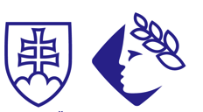

Autism (from the Greek “autos” – self, and “ismos” – orientation, state) means actively withdrawing from external reality into an internal, imaginary world. Autism is not an illness, but a developmental disorder. All forms of it have a common thread – the disruption of behaviour among and communication with other people. For this reason, it is difficult for many parents to make a relationship with an autistic child.

AH production
in co-production with Andreas
and RTVS Rozhlas a televízia Slovenska
present the documentary film

So Far, So Near

Silvia, high-functioning autism

Jakub, infantile autism

Milan, atypical autism

Andrej, autism

CLOSING TITLES

Our sincere gratitude to those appearing in the film
the Nakládal family
the Széher family
the Šóth family
the Vyskočil family
the Štubeň family
Filip Duba
Laimon Šalnaite
Simon Provost
Ivana Kuliffayová
Valéria Slivková
the Klenová family

Special thanks to
the Bohm family
Róbert Dando
Sky Color Foto
the Podolská family
Karin Brániková
Mons. Hajdu Arcibiskupský Office of the Bratislava Archdiocese
Marek Vadrna
Magdaléna Kusá
Mária Štubňová SPOSA
Martina Rumannova
management and staff of Billa supermarket
staff of the Kamzík chairlift
staff of the Bratislava Transport Company
Jana Janusová
Branislav Nágl
the St. Michal Hospital of Bratislava
Vincent Vojtek
Zuzka Vojteková
Martin Muráni of Kino X Stupava
Etela Hessová
Wilhelm Hess
Michal “EGO” Straka
Robert Burian
Gabriel Štanga
Jaromír Nohavica
Anna Harumová
Pavol Harum
Ivo Brachtl
František Palonder
Marián Petro
Dušan Trančík
Leo Štefankovič
Dagmar Franzenová
Darina Horáková
Martin Šmatlák
Bohumil Martinák

The creators of the film thank those who own the rights to the music and archives for their agreement of use

Items from archives of the Nakládal, Šóth and Vyskočil families were used in this film

Archives from contributions by Pomôže celé Slovensko
Krištáľové Krídlo (Crystal Wing) – Mária Vaškovičová

Archived Music
song title: Převez mě, příteli
album title: Doma
author of music and lyrics: Jaromír Nohavica
song title: Ako ty
music group: Cliché
album title: Do každej domácnosti
author of music and lyrics: Juraj Podmanický, Filip Goldberger
song title: Žijeme len raz
music group: EGO ft Robert Burian
author of music and lyrics: Robert Burian, Michal Straka

story: Jaro Vojtek
script: Jaro Vojtek, Marek Leščák
dramaturgy: Marek Leščák
RTVS dramaturgy: Mária Šnircová
original film music by: Michal Nejtek
sound: Dušan Kozák, Tobiáš Potočný, Adam Kuchta, Peter Harum, Sašo Bori, Michal Paluga
sound design and mixing: Dušan Kozák
sound mastering 5.1: Bohumil Martinák
colour correction: Peter Harum
editing: Peter Harum
camera: Noro Hudec ASK, Jaro Vojtek
technical cooperation: Peter Harum
translation of English subtitles: Janet Livingstone
English subtitles editing: Anna Kareninová
AH production production: Barbara Harumová Hessová
Andreas production: Lucia Gvozdjaková
Head of RTVS manufacture & production staff: Ivana Zlatňanská
RTVS production manager: Tibor Horváth
RTVS head dramaturge for documentary and educational production: Miroslava Tomaníková
Andreas Co-producer : Kateřina Nakládalová
AH production producer: Barbara Harumová Hessová
Director: Jaro Vojtek

This film was made and distributed with financial support from:

With financial support of the Ministry of culture of the Slovak republic

©
AH production, s.r.o.
Autistické centrum Andreas n.o.
RTVS – Rozhlas a televízia Slovenska
2014
www.takdalekotakblizko.sk/en

